

CT UNIVERSITY, PUNJAB INDIA
Python and Clean Coding Practicals

Submitted by – Muskan G

Registration No. - 72518605
Programme - BCA IBM ( AI & DS )

Submitted to - Mr. Nikhil Pandey



PRACTICAL – I

Basics of Python (Operators & Control Structures)
Aim:
To write basic Python programs using operators and control structures.

Program 1: Arithmetic Operators
Code:
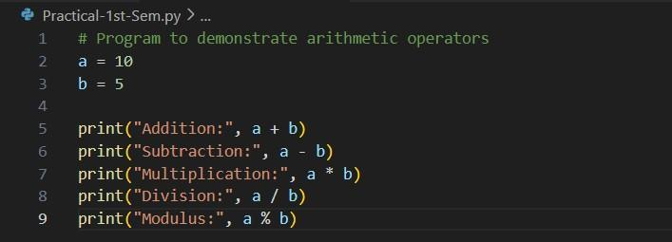
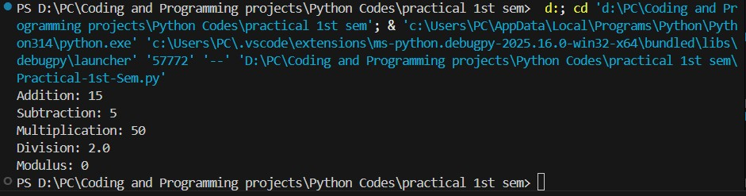

Output

Program 2: Largest of Two Numbers
Code:
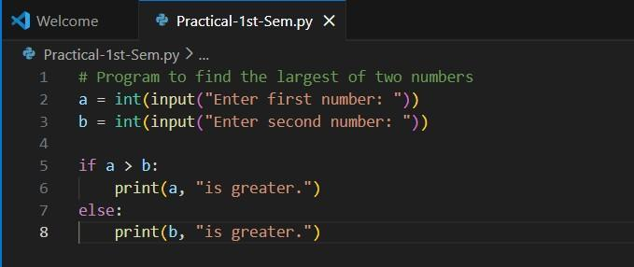
Input:
Enter first number: 5
Enter second number: 9

Output:
9 is greater.
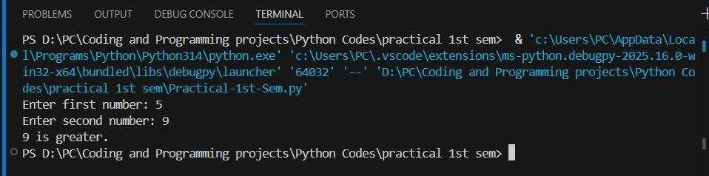
Conclusion:
Basic operators and control structures were executed successfully.

PRACTICAL – II

Data Structures in Python
Aim:
To implement operations using Lists, Tuples, and Dictionaries.

Program 1: List
Code:
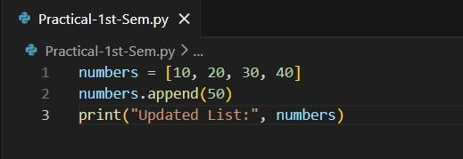
Output:
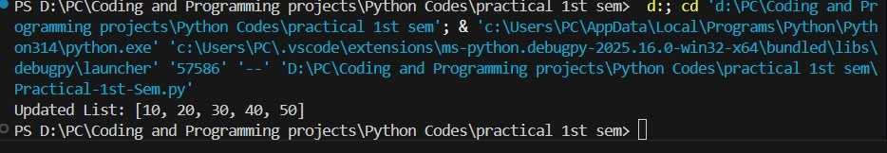

Updated List: [10, 20, 30, 40, 50]

Program 2: Tuple
Code:
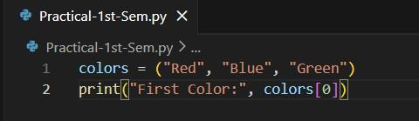
Output:
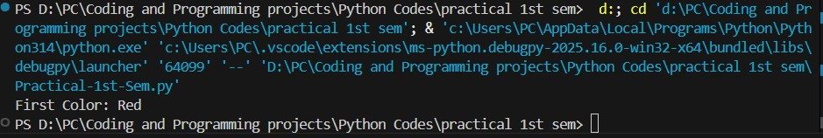

First Color: Red

Program 3: Dictionary
Code:
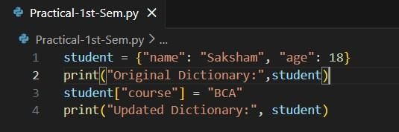

Output:
Original Dictionary: {'name': 'Saksham', 'age': 18}
Updated Dictionary: {'name': 'Saksham', 'age': 18, 'course': 'BCA'}
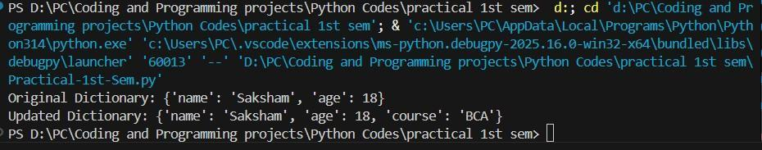
Conclusion:
List, tuple, and dictionary operations were implemented successfully.

Find the Largest Number in a List
Aim:
To write a Python program to find the largest number in a list.
Code:

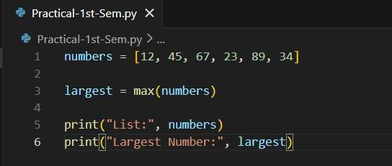
Output:
List: [12, 45, 67, 23, 89, 34]
Largest Number: 89
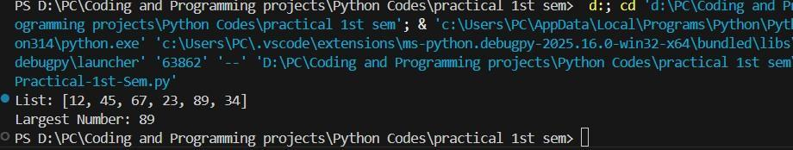
Conclusion:
Successfully found the maximum number in the list.

Add a Key-Value Pair to Dictionary
Aim:
To write a program that adds a key–value pair to a dictionary.
Code:
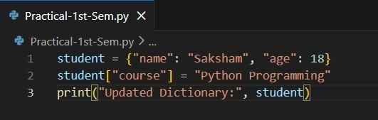

Output:
Updated Dictionary: {'name': 'Saksham', 'age': 18, 'course': 'Python Programming'}
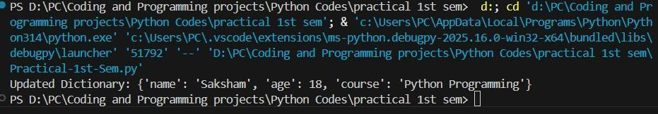
Conclusion:
Key-value pair insertion performed successfully.

Exception Handling
Aim:
To implement Python exception handling using try–except.
Code:
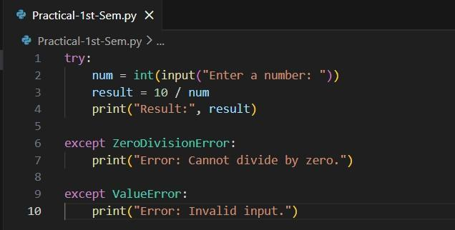

Input & Output Samples:
- Valid Input
Input:
Enter a number: 2

Output:
Result: 5.0
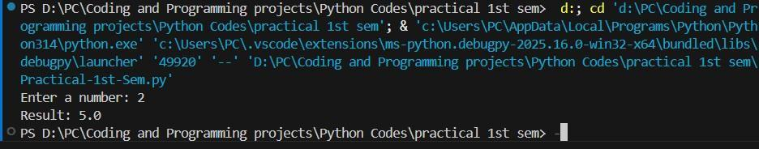
- Division by Zero
Input:
Enter a number: 0
Output:
Error: Cannot divide by zero.
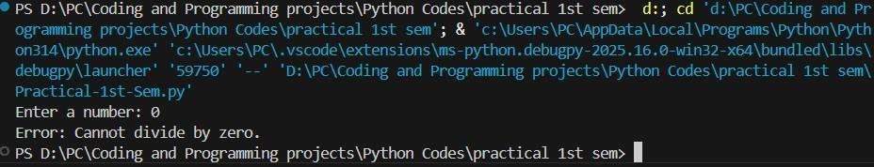
- Invalid Input
Input:
Enter a number: abc

Output:
Error: Invalid input.
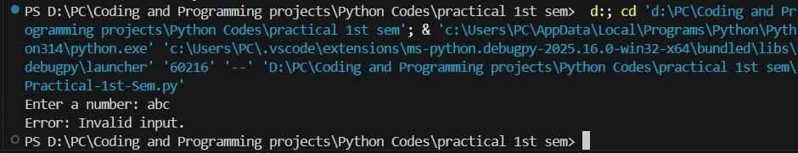

Conclusion:
Program handled runtime errors safely using exceptions.

PRACTICAL – VI

Visualization using Matplotlib

Aim:
To visualize data using bar and line charts.
Code:
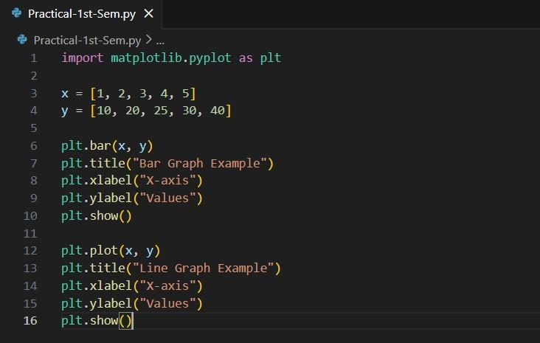
Output Description:
Bar Graph:
- Shows bars at heights 10, 20, 25, 30, 40
- X-axis values: 1–5
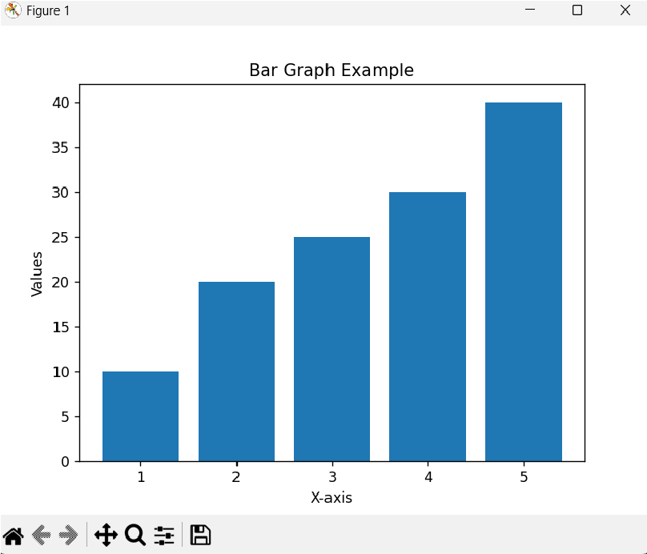

Line Graph:
- Line passes through points:
(1,10), (2,20), (3,25), (4,30), (5,40)
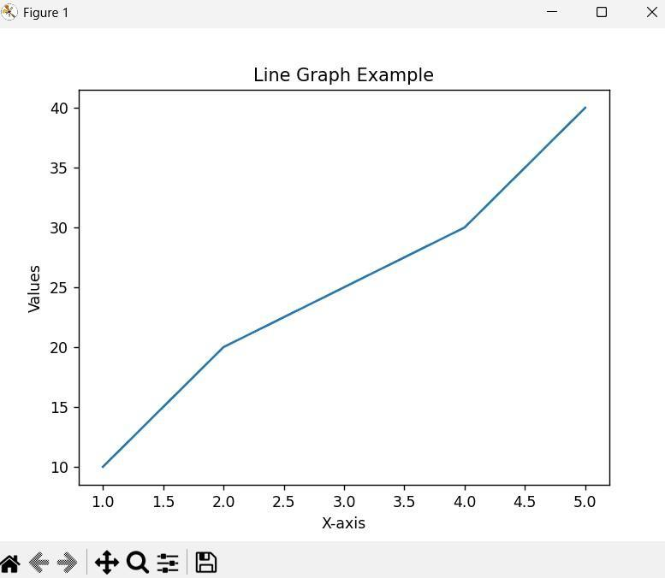
Conclusion:
Data visualization with matplotlib was successfully performed.

File Handling
Aim:
To perform read/write operations on a file.
Code:
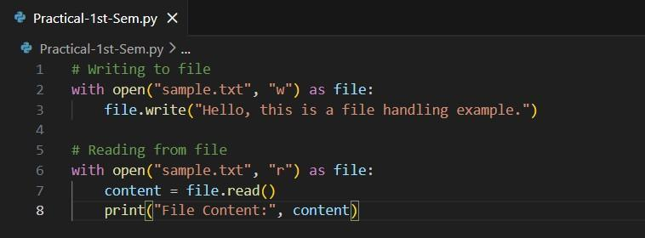
Output:
(sample.txt created successfully)
File Content: Hello, this is a file handling example.
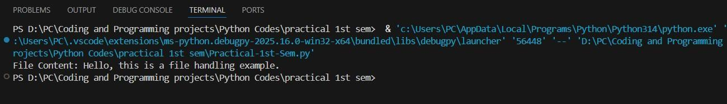
Conclusion:
File read/write operations executed successfully.

Machine Learning – Linear Regression
Aim:
To implement linear regression using Python and scikit-learn.
Code:

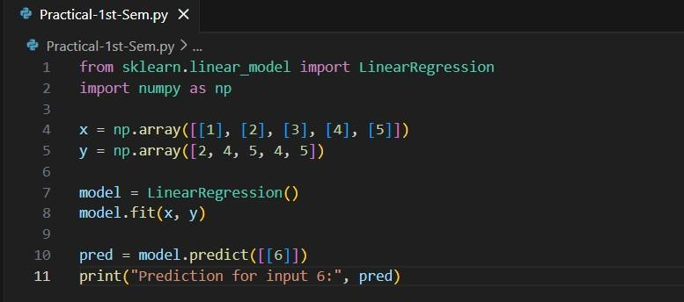

Output:
Prediction for input 6: [5.8]
Conclusion:
Linear regression model trained and tested successfully.

Decision Tree
Aim:
To implement a Decision Tree classifier.
Code:
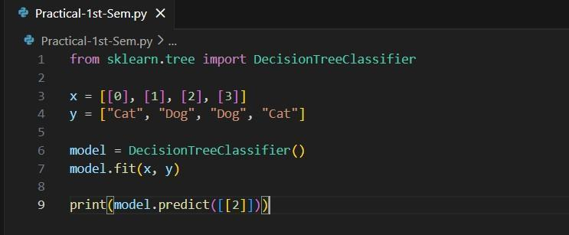
Output:
['Dog']
Conclusion:
Decision tree trained and prediction executed successfully.

Random Forest
Aim:
To implement a Random Forest classifier.
Code:
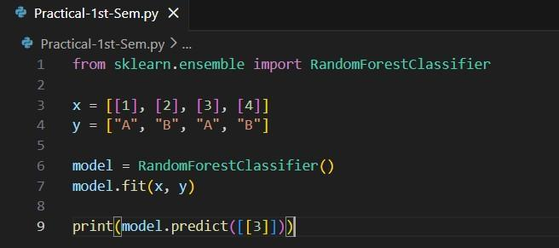
Output:
['A']
Conclusion:
Random Forest classifier implemented successfully.

